AT: Growth Bad (Frontline)

1. Empirically denied—there has been growth and development since the agricultural revolution

2. No growth leads to extinction
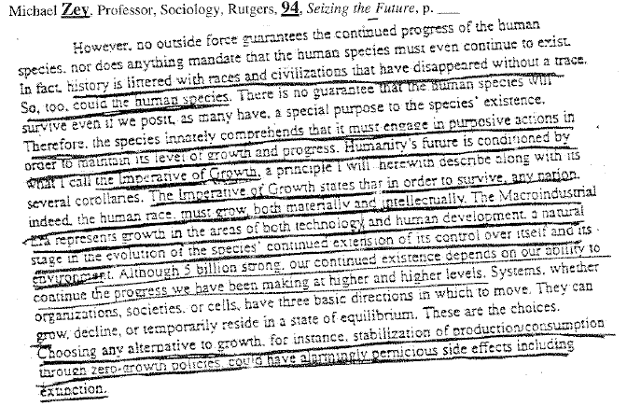

Transition is impossible and only growth solves nuclear war
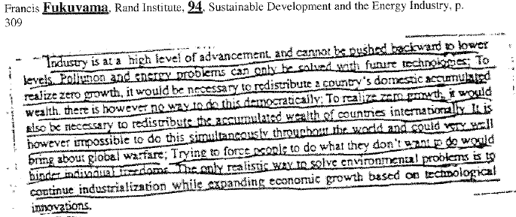

AT: Growth Bad (Frontline)

Growth can only lead to better regulations and techonology
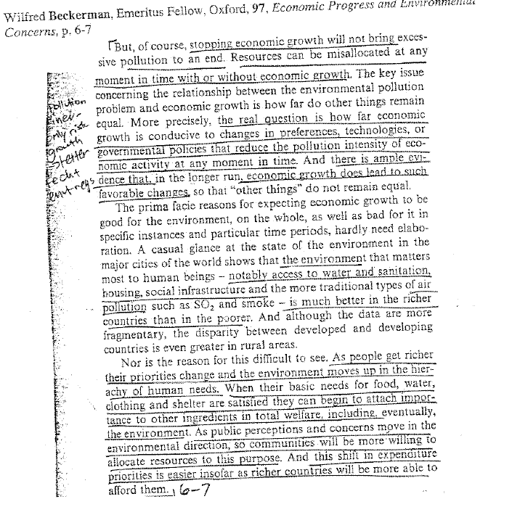

AT: Growth Bad (Frontline)

Technology solves risk of scarcity

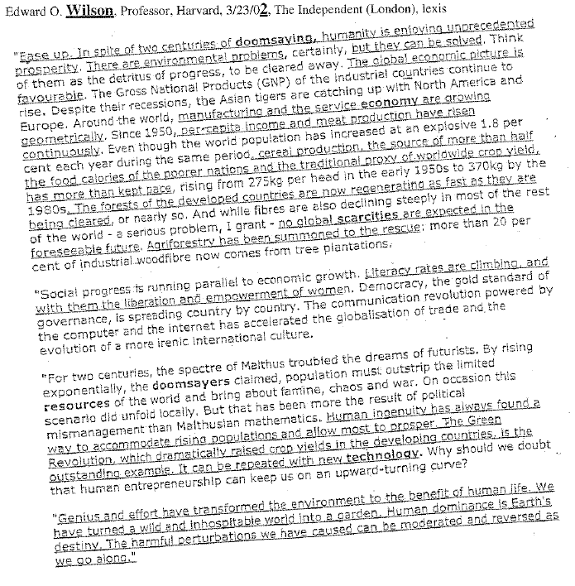

AT: Growth Bad (Frontline)

Steady state economy empirically destroys the environment
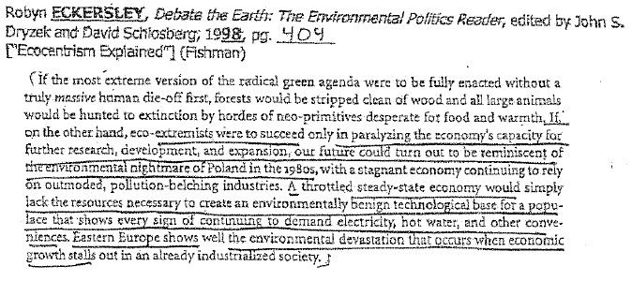

2NC EXT—Zero Growth Bad

1. Zero growth causes extinction—Zev 94 says growth and advancement are key to human survival—past zero growth societies have become extinct

2. The only choice we have is growth vs. collapse
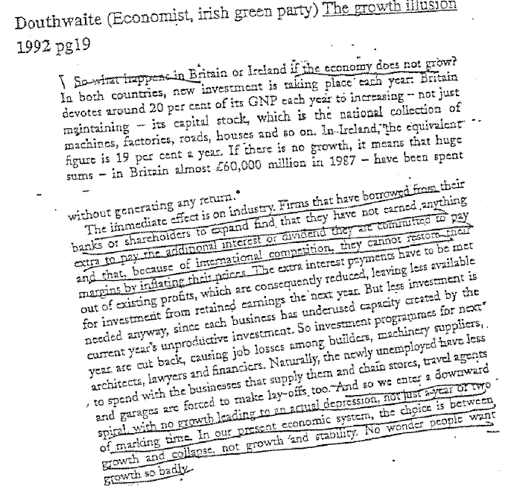

2NC EXT—Growth Solves Scarcity
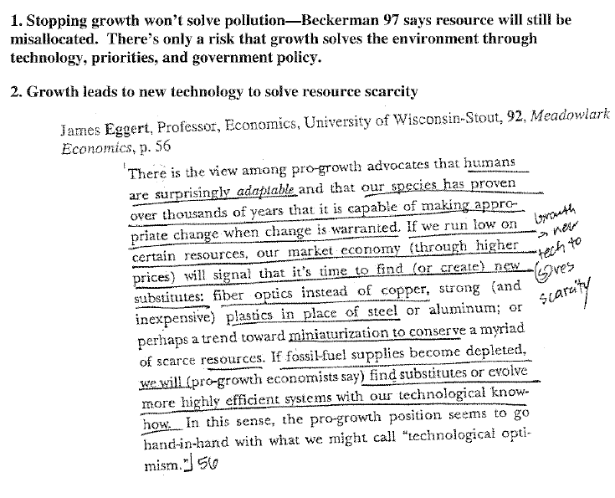

2NC EXT—Transition Wars
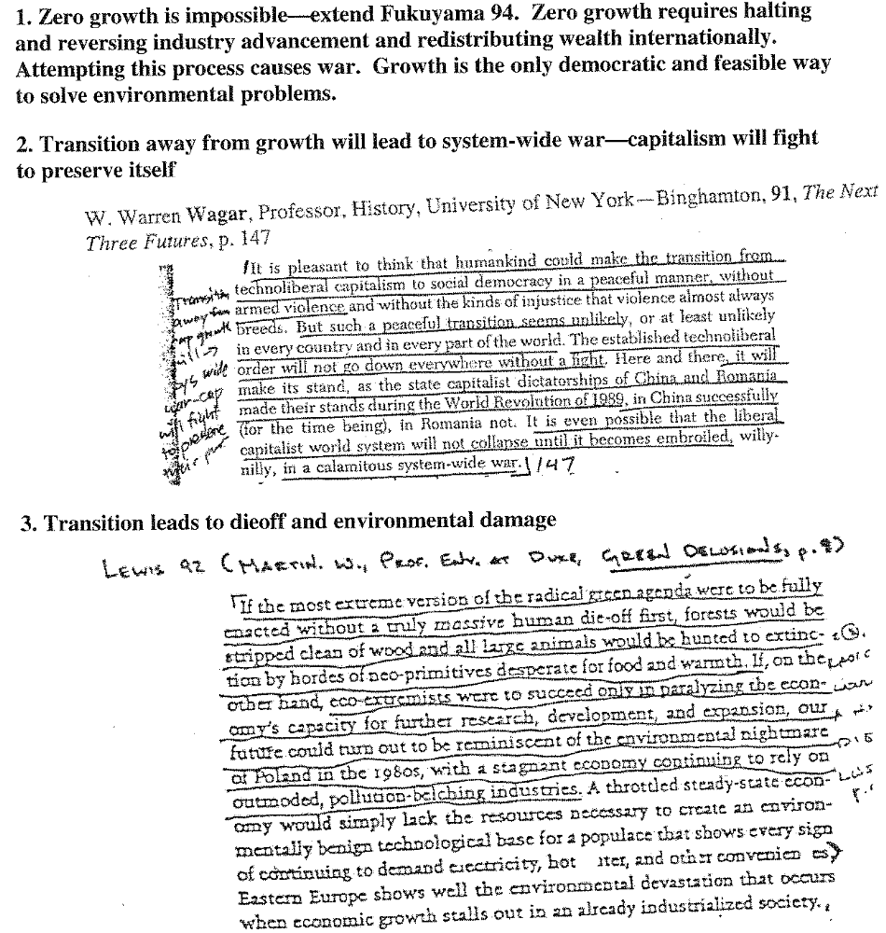

Turn: Population Growth(1/2)

1. Returning to local self-sufficiency increases population
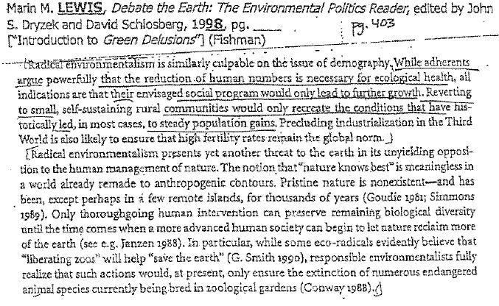

Turn: Population Growth (2/2)

2. Population growth causes massive death
Garret Hardin, University of California, Santa Barbara, Spring ’91, Population and Environment

